Theme: Selecting Appropriate Approaches for Restoration
Visit regenTV - http://www.aabr.org.au/regentv/

Relevant section of the National Standards -http://seraustralasia.com/standards/contents.html
Principle 2. Restoration inputs will be dictated by level of resilience and degradation
All species (and therefore ecosystems) possess a capacity to recover naturally from external stresses or disturbances to which they were exposed during their evolution. This can be harnessed for restoration as long as the type and degree of degradation is not too dissimilar to the natural stresses and disturbances to which the species are adapted. For example, fire-adapted species are adapted to the stresses associated with fire and periods without fire, freshwater species are adapted to flooding and drying; and montane species are adapted to freezing and thawing.
If degradation levels are low recovery can necessarily spontaneously occur when you remove the cause of degradation. But for intermediate levels of degradation recovery may not spontaneously occur as seeds may be dormant in the soil seed bank, for example, and require a particular disturbance (or provision of other triggers) to kick start recovery (as that is what happens in nature). Where impacts are very high, little regeneration capacity may remain and the plants and animals need to be reintroduced.
Implications to practice: Variation in the regeneration capacity of different sites or parts of sites dictates that the ecological condition/resilience of all zones must be carefully assessed ahead of prescribing whether regeneration-based or reconstruction-based approaches are needed (Box 2 of Standards).
This analysis can also assist prioritisation. That is, it can be beneficial to start work in parts of a project area with higher regeneration potential and progressively work outwards from those areas, building on the strengths of the site rather than attempting to focus on repairing its weaker areas first.
How do you assess resilience of native vegetation on a site? You look for:
1. signs of ‘in situ’ resilience, (e.g. intact soil profiles that indicate at potential soil seedbank – or any remaining rootstocks ) and;
2. signs of ‘migratory’ resilience (i.e. potential for seed rain or dispersal by fauna from nearby areas).
A search of the literature will allow you to identify that there are some useful general principles:
- Resprouters – i.e. species that live longer as adults (relative to other members of their community) tend NOT to form a persistent soil seed bank (i.e. greater than, say, 1 year) but most of these DO tend to be capable of resprouting from rootstocks and broken stems (and some of these hold their seed in the canopy for 1 year or longer). Mostly these are the ‘dominants’ and sub-dominants in a community. Because they are longer-lived they can sometimes persist as adults on degraded sites (unless sensitive to the degradation type).
- Obligate seeders – i.e. species that are short lived as adults(relative to other members of their community) are more likely to form a persistent soil seed bank. So while they may not persist as adults on a degraded site, they may persist in the soil seed bank.
Note: Some species do not fit into either category and require special consideration.
Once you have an idea of what might be missing or potentially still present you need to identify how to trigger germination or colonisation of plants. Germination could be cued by natural disturbances such as fire, flooding or soil disturbance. Colonisation might require preparing the site to ensure the appropriate hydrology, appropriate soil chemistry and lack of competition from weeds; or that habitat elements are present (e.g. bird perches or shelter for animals) to allow fauna to bring seed onto site.
Restoration – whether using regeneration-based approaches or a reconstruction approach (i.e. reintroductions) - can be seen as a process of removing obstacles to a natural recovery trajectory.
That is, obstacles (or barriers as indicated in the diagram below) can occur at any point along the recovery trajectory and prevent further recovery. These obstacles can be due to conditions preventing recovery from propagules already available (e.g. substrate unsuitability, habitat unsuitability, excessive competition from particular species and so on) OR they may be the very absence of propagules along with suitable conditions. Once each obstacle is overcome, recovery can continue in an upward direction until full recovery is attained.
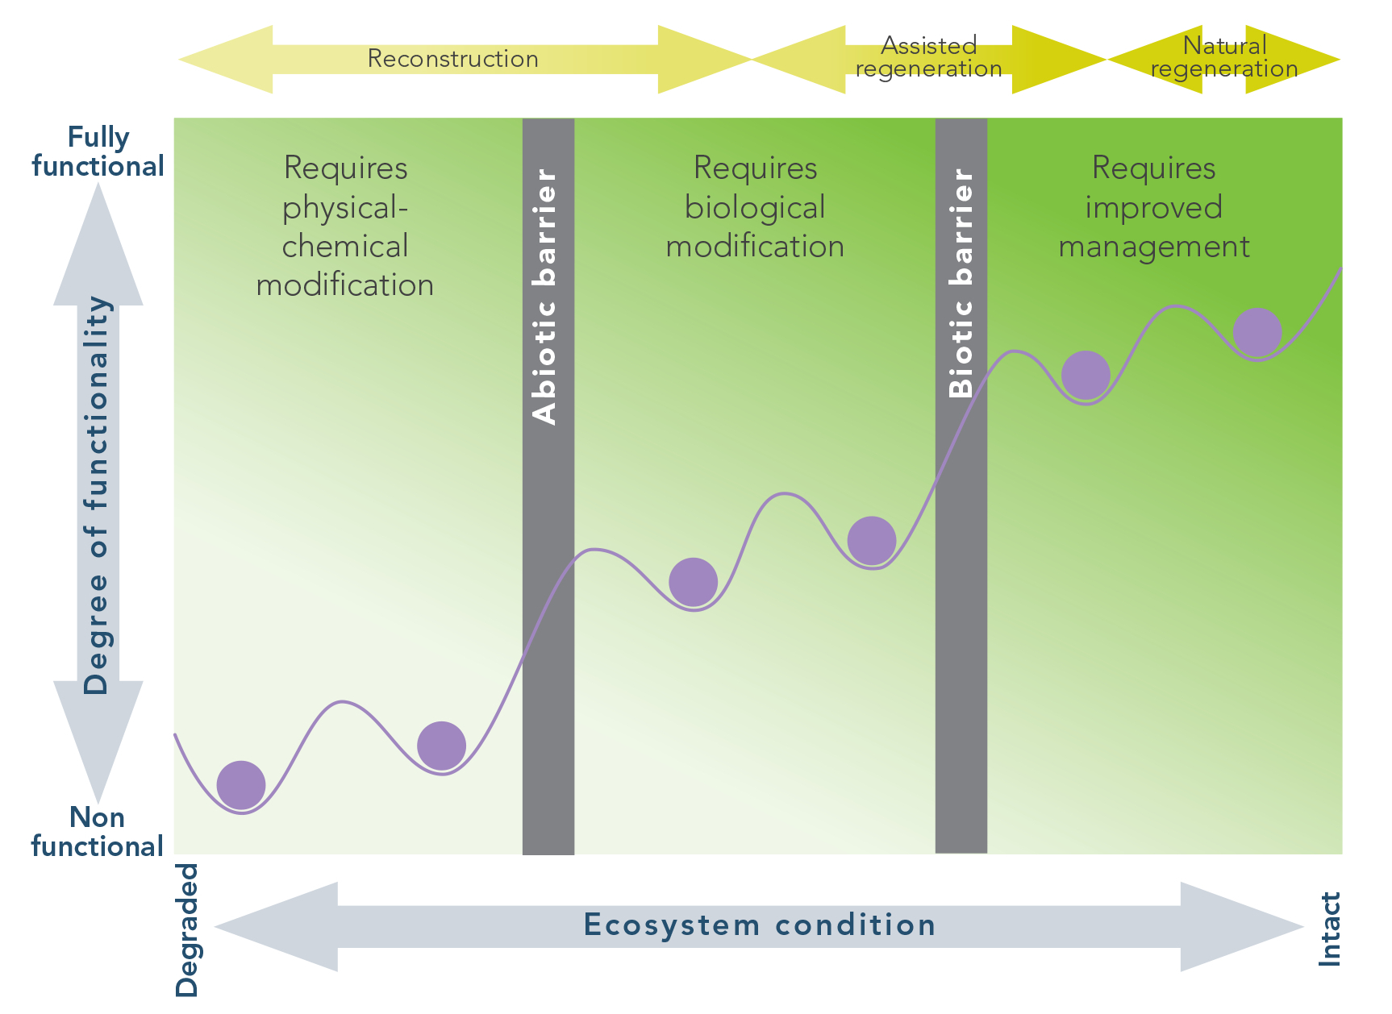

Figure 1: Conceptual model of ecosystem degradation and restoration. (From The National Restoration Standards and adapted from Keenleyside et al 2012, after Whisenant 1999, and Hobbs & Harris 2001).
The troughs in the diagram represent basins of stability in which an ecosystem can remain in a steady state prior to being shifted by a restoration or a degradation event past a barrier (represented by peaks in the diagram) towards a higher functioning state or a lower functioning state. [Note: Some projects may already start at a higher condition and not all sites in need of physical/chemical amendment depend upon reintroduction for the return of biota.]
Fauna: While this worksheet focuses on vegetation, the concept of resilience can also be applied to fauna. Indeed it is often assumed that fauna will naturally colonise a degraded site once habitat has been reinstated; although this is not always the case. In some cases fauna may need to be reintroduced if that is technically possible and if the appropriate licences and ethics permits are in place.

