Australian Association of Bush Regenerators (NSW) Inc.
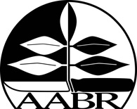
postal address c/- Total Environment Centre, Suite 2, 89 Jones Street, Ultimo NSW 2007
phone 0407 002 921 email enquiries@aabr.org.au website www.aabr.org.au
ABN 33 053 528 029

V’n 2013/06

Advertising AABR Member Businesses on the AABR website!

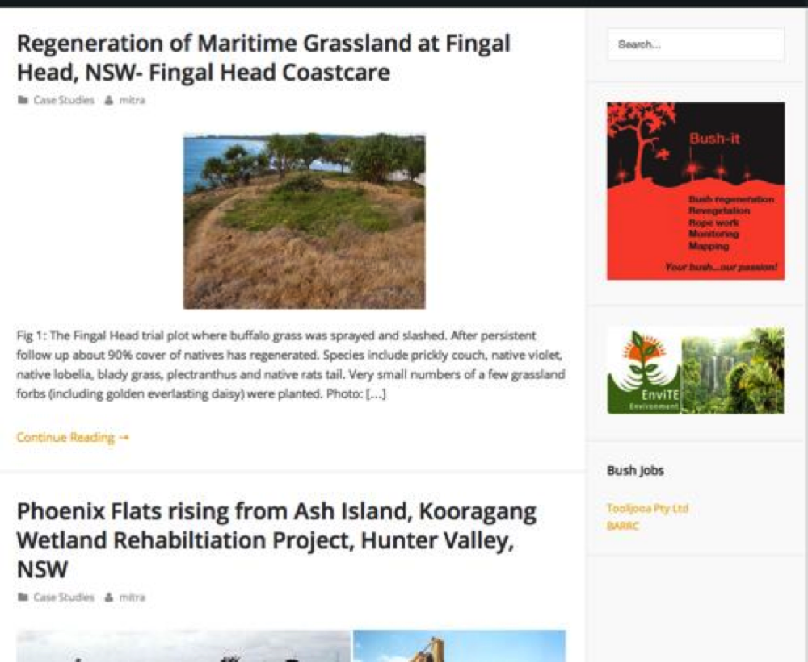
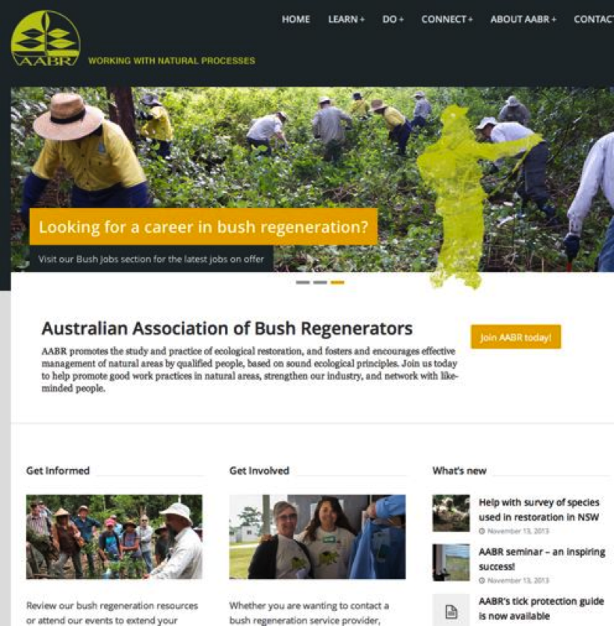

Background

- Our website receives about 1 million visits a year!
- It is a main point of access for contacts and information for many clients of the natural area restoration industry and others.
- We hope that we can provide you with an opportunity to secure work through advertising your business on our website.
- At the same time, you will be supporting the work AABR does to foster and encourage sound ecological practices of bushland management by qualified people.

AABR provides the opportunity for its members to advertise their relevant businesses on our website. A range of advertising options are available to AABR members. These range from banner advertisements to your business details appearing on the Professional Listings section of the site, under 1 or more of the 3 categories:
- Consultant
- Contractor
- Plant/Tool Supplier

The criterion for advertising is that the Principal, Owner or Manager / Director of the business is an financial AABR member with AABR accreditation as a practicing bush regenerator. The name of the member will be included in the listing. If desired, the name of ONE additional employee of the business may also be displayed on our website. The criteria for this person to be listed is that they hold the position of supervisor or higher (in the case of Contractors) and that they are financial AABR members.

To check your business details on our website at any time, go to www.aabr.org.au and visit the “Professional Services” section, then click on any of the 3 categories, as indicated above.

NOTE: Being advertised on AABR’s website is not in itself an endorsement by AABR of a business and AABR takes no responsibility in respect to the quality of works.

Want to advertise your business?

- STEP 1: Ensure your AABR accredited membership is up to date.
- STEP 2: Choose an Advertising Option (page 2).
- STEP 3: Complete the Application Form below (pages 3 & 4).
- STEP 4: Email your application form to: advertise@aabr.org.au

Advertising Features:

A) BASIC: Your business details will be posted on your own AABR web-page
- The details you provide in sections 1 to 6 below will be listed on your own AABR web-page.

B) EXTRA TEXT: Add more information about your business on your AABR web-page
• Add extra details about your business to your AABR web-page.
- Up to 500 words may be posted.

C) IMAGE: Put a unique graphic on your AABR web-page
- Post your business logo and a photo of you or your work on your AABR web-page.
- Maximum 1 logo + 1 image.
- Must be provided in .jpg or .gif format.
- Maximum 50 kB file size for each image.
- Logo must be 150 pixels wide and 75 pixels high.
- Additional image must be 675 pixels wide and 200 pixels high.

D) BANNER ADVERT GOLD: Get your business seen with advertising on the AABR website
- Your advert will link to your own website or your AABR web-page.
- Your advert will appear across the AABR website (not including the home page), in rotation with other adverts in the ‘Gold category (see “Advertising Options” below).
- GOLD banner adverts will be placed below the GREEN banner adverts
- Must be provided in .gif or .jpg format.
- Must be 220 pixels wide and 110 pixels high.
- Maximum 30 kB file size.

E) BANNER ADVERT GREEN: Get your business seen with advertising on the AABR website
- Your advert will link to your own website or your AABR web-page.
- Your advert will appear across the AABR website (not including the home page), in rotation with other adverts in the ‘Green’ category (see “Advertising Options” below).
- GREEN banner adverts will be placed above the GOLD banner adverts
- Must be provided in .gif or .jpg format.
- Must be 220 pixels wide and 220 pixels high.
- Maximum 50 kB file size.

Advertising Options:
 | FEATURES [see above]
OPTIONS | Basic | Extra Text | Image | Banner Advert |  | COST p.a. [inc. GST]
 |  |  |  | GOLD | GREEN | COST p.a. [inc. GST]
Option 1: Basic | √ |  |  |  |  | $50
Option 2: Extra | √ | √ | √ |  |  | $100
Option 3: Banner Silver | √ |  |  | √ |  | $250
Option 4: Banner Gold | √ | √ | √ | √ |  | $300
Option 5: Banner Green | √ | √ | √ |  | √ | $400

More details:
- Professional fees are charged only once per year, whether you list under 1, 2, or 3 categories.
- Businesses will be listed as soon as practicable, usually within a week.
- A pro rata rate for a given year may be arranged when applying for listing.
- If you list under more than one category, the same text & image will appear under each.
- Professional fees are due at the same time as membership fees, i.e. based on the financial year.
- An update of the Professional lists is expected to be made once each year, free of charge.
- Changes may be made at other times, the cost set by our Web Contractor, usually around $20.
- There is no refund for removing your listing, but there is no charge for doing so.
Australian Association of Bush Regenerators (NSW) Inc.
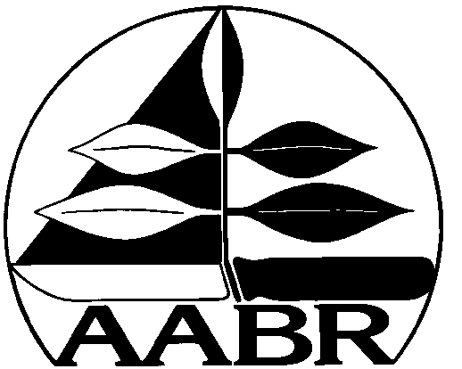
postal address c/- Total Environment Centre, Suite 2, 89 Jones Street, Ultimo NSW 2007
phone 0407 002 921 email enquiries@aabr.org.au website www.aabr.org.au
ABN 33 053 528 029

V’n 2013/01

AABR Website - Professional Listing Application Form

Please submit the details below by email to: advertise@aabr.org.au

1. Advertising Option:
I would like to choose Advertising Option No. (see p.2 above): _____

2. Professional Categories:
I would like to advertise my business under the following categories:
Y / N Consultant
Y / N Contractor
Y / N Plant/Tool Supplier

3. Business Details:
Please provide the following information:

Main accredited AABR Member – Name: __________________________________________________
– Position in the business: ___________________________________

2nd accredited AABR Member – Name: ____________________________________________________
(NOT compulsory)
– Position in the business: ____________________________________
Business name: _______________________________________________________________

Postal address: _______________________________________________________________

Telephone No. (landline): _______________________________________________________

Fax No.: _____________________________________________________________________

Mobile No.: __________________________________________________________________

Public email address: __________________________________________________________

Web address: _________________________________________________________________

ABN: _______________________________________________________________________

Regions of operation – SEE “AABR Regions” at the end of this form.
Indicate here which regions you wish to offer your services.
_____________________________________________________________________________

4. Services Provided:
Please indicate which of the following services you provide and wish to advertise.

Y / N Weed treatment - Hand tools, backpack sprayer
Y / N Weed treatment - Vehicle mounted spraying
Y / N Weed treatment - Tree climbing / felling
Y / N Weed treatment - Abseiling / rope work
Y / N Weed treatment - Mechanical clearing
Y / N Fire hazard reduction works
Y / N Planting – Hand
Y / N Planting - Mechanical means
Y / N Erosion control - Hand tools
Y / N Earth works - wetland, creekline & stormwater works
Y / N Earth works - other (eg. scalping, capping, reshaping, topsoil translocation)
Y / N Infrastructure construction / installation (eg. tracks, boardwalks, retaining walls, fences, signs)
Y / N Seed collection, storage and/or supply
Y / N Plant supply
Y / N Pest animal control
Y / N Training
Y / N Supervision
Y / N Education and Awareness
Y / N Facilitation
Y / N Flora surveys
Y / N Fauna surveys
Y / N Mapping
Y / N Ecological monitoring
Y / N Plans of management
Y / N Property planning
Y / N General consultation
Y / N Other (max. 10 words):

5. Advertising Feature – Extra Text:
If you are choosing this feature, write your text here (up to 500 words):

6. Advertising Features – Image, Logo AND Banner Advert:
If you are choosing either of these features, attach electronic versions when you email this form.
AABR Regions

KEY:
(N) = northern boundary
(S) = southern boundary
(W) = western boundary

NSW:
- Far North Coast: Queensland border (N); Coffs Harbour (S); Great Dividing Range (W).
- Lower North Coast: Sawtell (N); Seal Rocks (S); Great Dividing Range (W).
- Hunter: Myall Lakes – Hunter River catchments (N); Lake Macquarie catchment (S); Great Dividing Range (W).
- Central Coast: Lake Munmorah catchment (N); Hawkesbury River (S); Great Dividing Range (W).
- Sydney: Hawkesbury River (N); Nattai – Picton – Appin – Helensburgh (S); Nepean River – Lake Burragorang + Emu Plains (W).
- Illawarra: Otford (N); Gerroa (S); Great Dividing Range (W).
- Shoalhaven: Berry (N); Termeil (S); Great Dividing Range (W).
- South Coast: Batemans Bay (N); Victorian border (S); Great Dividing Range (W).
- Blue Mountains: Hawkesbury-Nepean River minus Emu Plains (E); Lithgow (W).
- Southern Highlands: Thirlmere (N); Marulan (S).
- Northern Tablelands
- Central Tablelands
- Southern Tablelands
- Western NSW: Outside the above areas.
ACT
QLD:
- SE Queensland: Toowoomba – Gympie line (N); NSW border (S) except Brisbane (see below).
- Brisbane: Redcliffe-Kallangur (N); Beenleigh (S).
- Other: (please define)
VIC
SA
NT
WA
TAS
Specific areas of Operation: [NB: You MUST still identify at least ONE of the above regions.]

Payment:

PLEASE NOTE THAT PAYMENT DETAILS ARE DIFFERENT TO MEMBERSHIP PAYMENT OPTIONS

There are 2 ways to make a payment:

OPTION 1: Cheque/Money Order
Make a Cheque or Money Order out to “Ilk Media”.
Post your Cheque or Money Order to: Ilk Media, 21 James Street, Enmore NSW 2042.

OPTION 2: Internet Banking
Transfer your payment on line from your financial institution to Ilk Media’s bank account.

Account name: Ilk Media.
Bank: CUA
BSB: 814-282
Account No: 10679865

Remember you MUST also:
* QUOTE YOUR INVOICE NUMBER against the deposit, so it appears on our statement, AND
* SEND AN EMAIL to accounts@ilk.com.au stating:
- Your name
- Date of payment
- Amount paid
- Advertising Option chosen

[By doing so we are able to match your payment against your name. We can also
confirm your option and distinguish between multiple year payments.]

